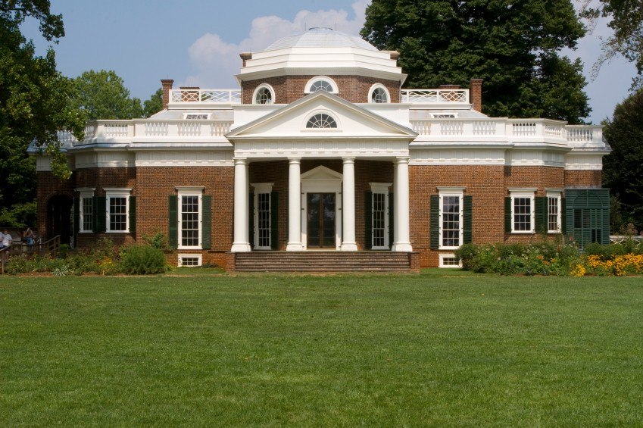

Thomas Jefferson’s Home, Monticello, in Charlottesville, VA (1770-1806)

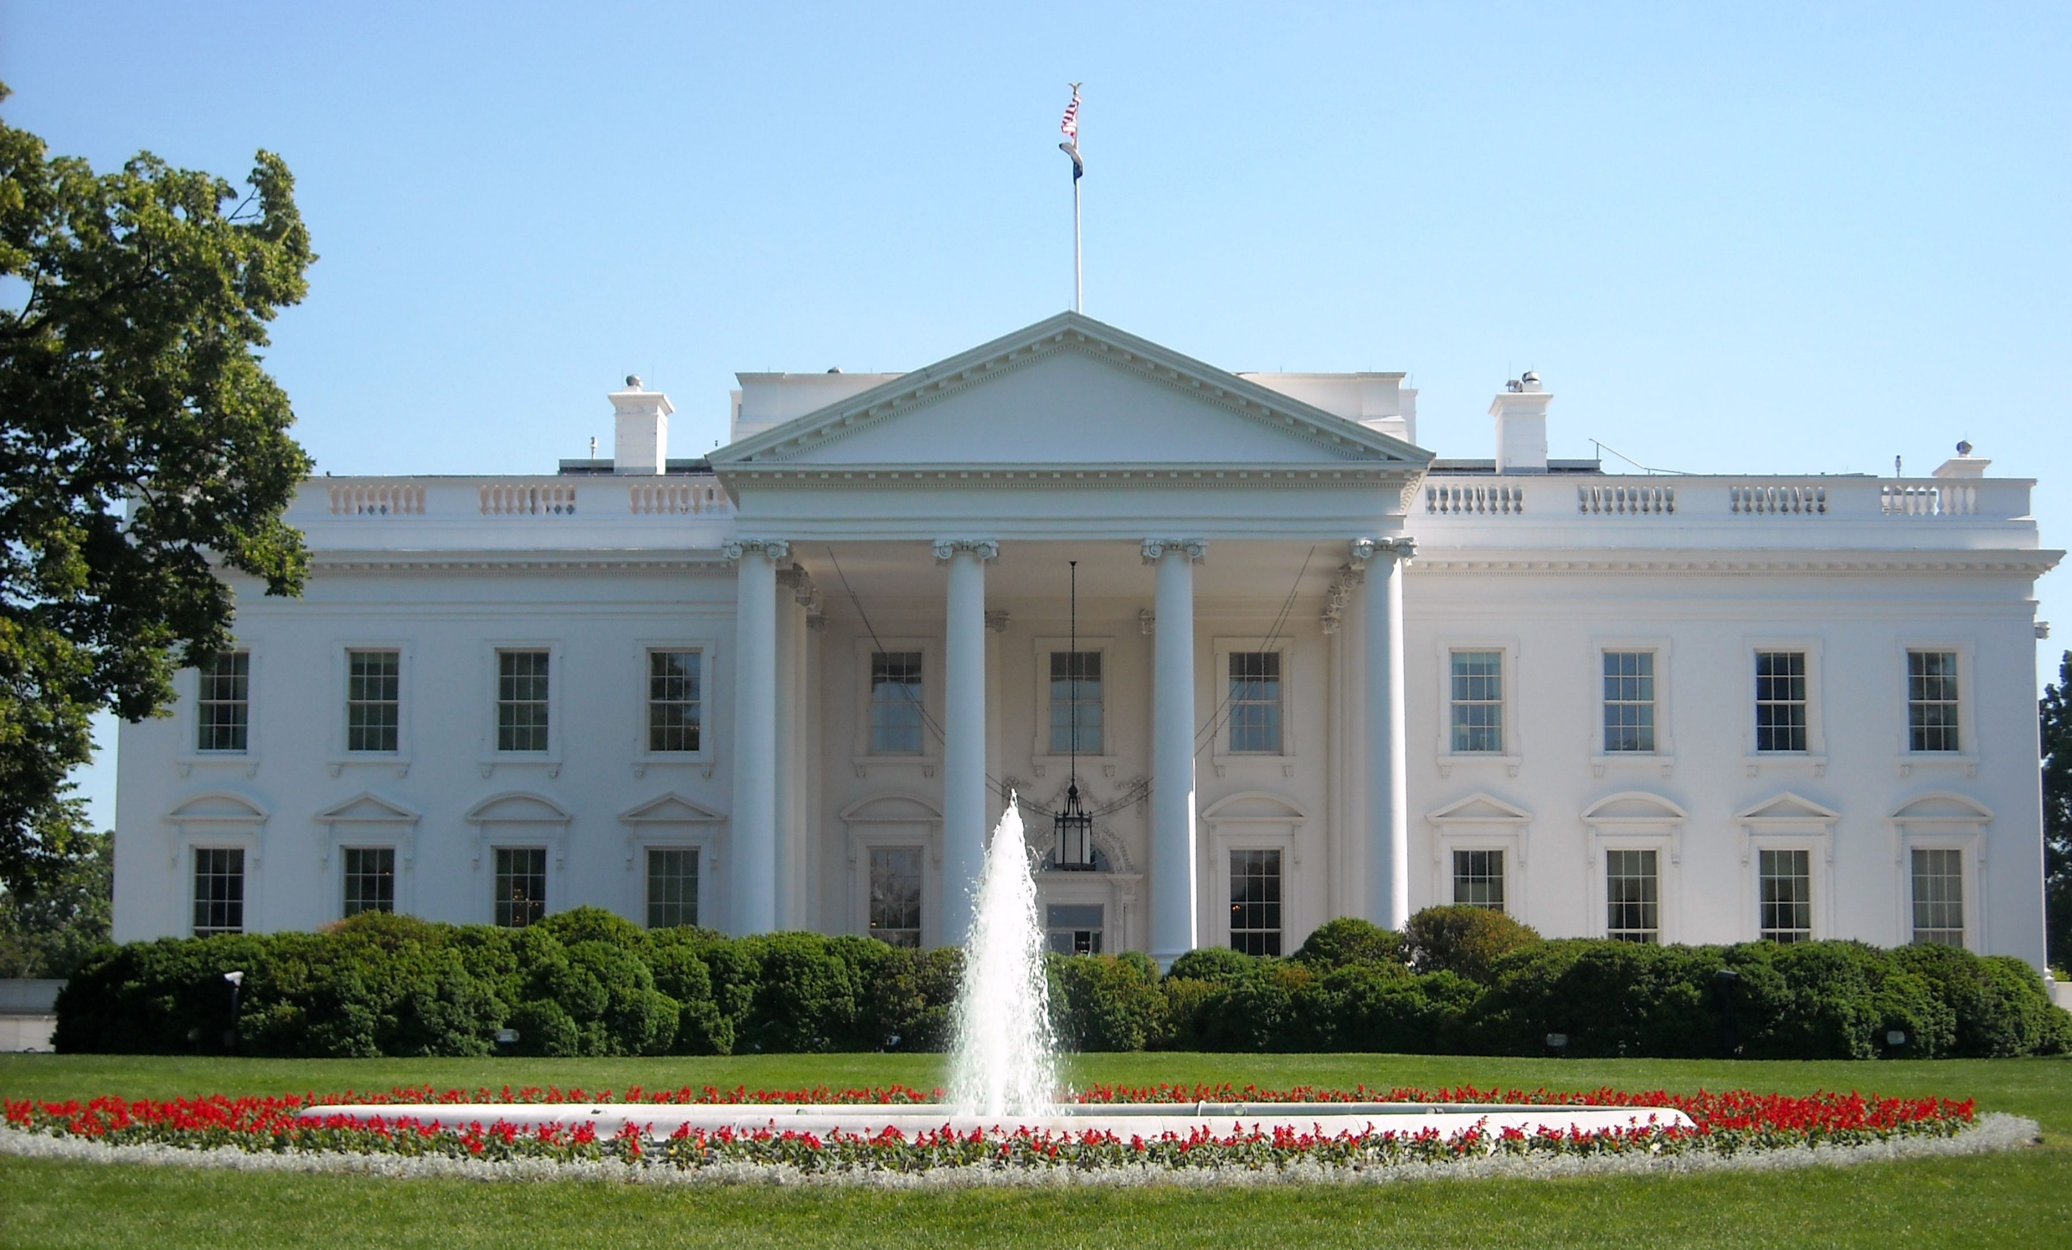
The White House -1792

